**ED-TECH INSTITUTE OF TECHNOLOGY  
  
DEPARTMENT OF DATA SCIENCE AND ANALYSIS  
  
CANDIDATE: THUTO MASOLE  
  
PROJECT 2: EXPLORING TRENDS IN HAPPINESS**

**Abstract**

This study delves into the intricate web of factors influencing happiness levels across various demographics. While the direct causality between variables such as freedom, trust in governance, GDP per capita, family, and happiness is explored, the broader perspective suggests that happiness is more of a manifestation of overall well-being. Recognizing this, the report emphasizes an in-depth exploration of trends in happiness, placing particular emphasis on issues with a potentially profound impact on individual well-being. Among these, GDP per capita and health emerge as pivotal determinants, underscoring their significant influence on an individual's overall sense of happiness and contentment. By illuminating these trends, this research aims to provide insights that could inform policies and interventions geared towards enhancing societal well-being.

**Introduction**

Without any delay, this report provides scholarly approved explanations to derived insight. For instance, the Global Multidimensional poverty index 2023 provides relevant information to explain the current health and GDP per Capita trends in Africa. Relevant in the sense that it acknowledges the significance of providing multidimensional solutions to deprivations people experience. It measures deprivations across health, education and standard of living. 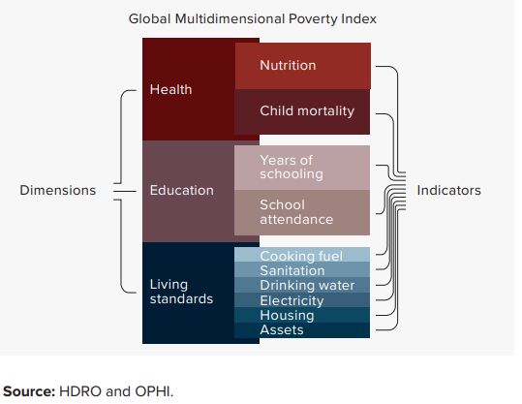

Prior to literature review of happiness, the foundation of this exploratory analysis rests upon basis that happiness is better understood as a manifestation of contentment with the least deprivations ,rather unhappiness. It explains why initial research questions are:

**On average, how happy are people across the world?**

The average happiness score across all data is 5.46 , there has been fluctuations around this mean which could be a result of the constantly changing global socio-economic phenomena. As illustrated by the graph below, there is an oscillating trend in happiness in the entire world. Further research from the Human Development report 2021/2022 assert that the world has been covered by an aura of uncertainty and insecurity in terms of socio-economic welfare.

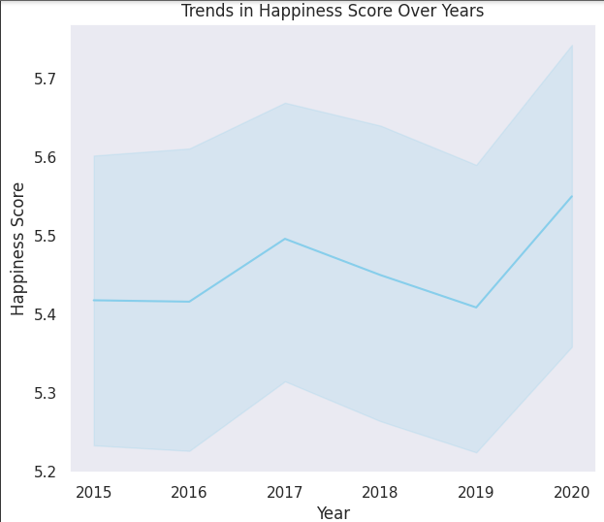

The observation above urges the exploratory analysis to find out factors leading to contentment or deprivations of either health and livng standards. The question herein is,

**What is the correlation between happiness score and other parameters?**

Analysis shows that there could be a strong positive correlation between health standards and GDP per capita as well as health standards and happiness score.

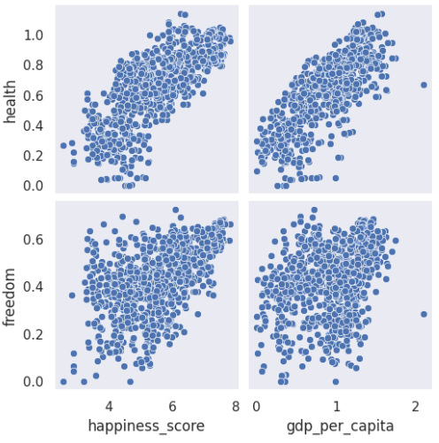

Therefore, in pursuit of deriving meaningful insight around happiness, it is vital to explore the trends in GDP per capita across continents. This can provide useful insight on understanding healthcare and happiness trends.

**What are the trends in GDP per capita across continents?**

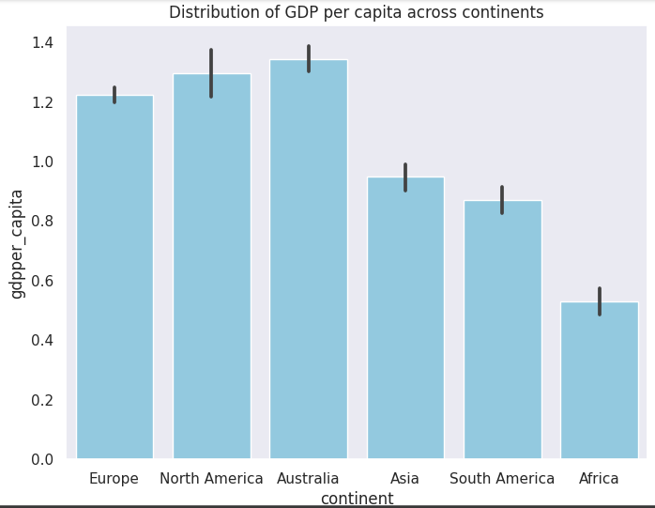

The observations hold that, Africa is the continent with the lowest GDP per capita averaging 0.53 Africa 0.529133

Asia 0.948058

Australia 1.342890

Europe 1.222620

North America 1.295400

South America 0.871571

Africa's low GDP per capita compared to other continents can be explained through the lenses of globalization and dependency theories. Globalization theory highlights challenges in Africa's integration into the global economy, including limited competitiveness, commodity dependence, and vulnerability to global market dynamics. Dependency theory emphasizes historical and structural factors, pointing to external dependence, unequal exchange, and limited autonomy in shaping economic policies.

**Looking into Africa**

In recent years, the discourse on human well-being has increasingly shifted towards holistic measures that encompass not only economic prosperity but also the overall quality of life and well-being. Africa, a continent rich in cultural diversity and natural resources, presents a compelling case study in this context. As we delve into the happiness trends in Africa, a fundamental question emerges: How happy are the people across its diverse landscapes?

This section of the report aims to explore this question by examining a spectrum of factors, ranging from economic metrics to health conditions, to offer a nuanced understanding of happiness trends in Africa. By integrating these multifaceted dimensions, we seek to unravel the intricate interplay between economic development, health outcomes, and subjective well-being, shedding light on the broader narrative of happiness in the African context.

**What are Africa Gdp per capita trends**

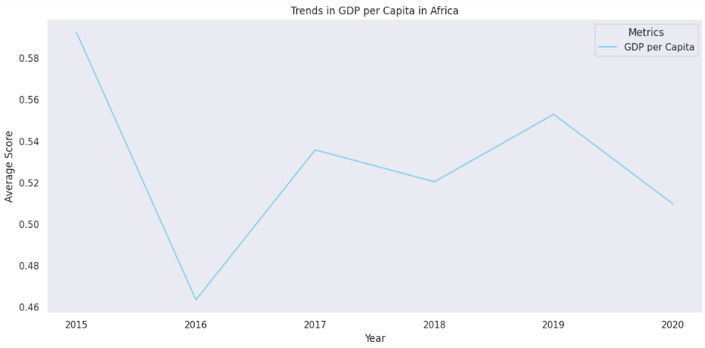

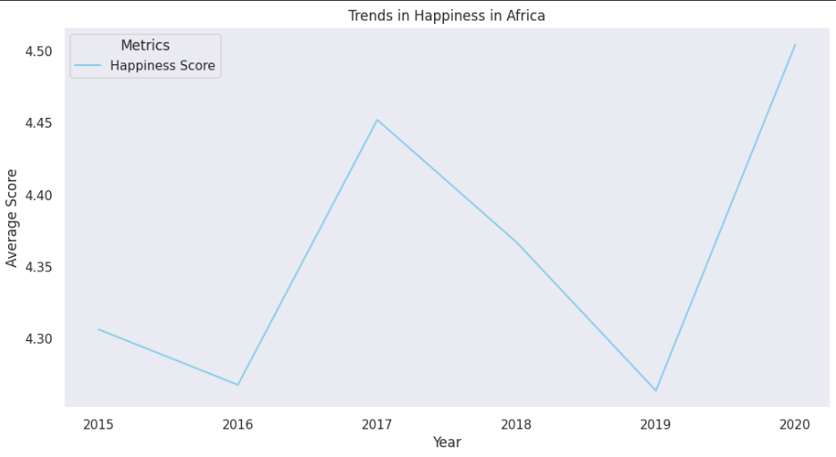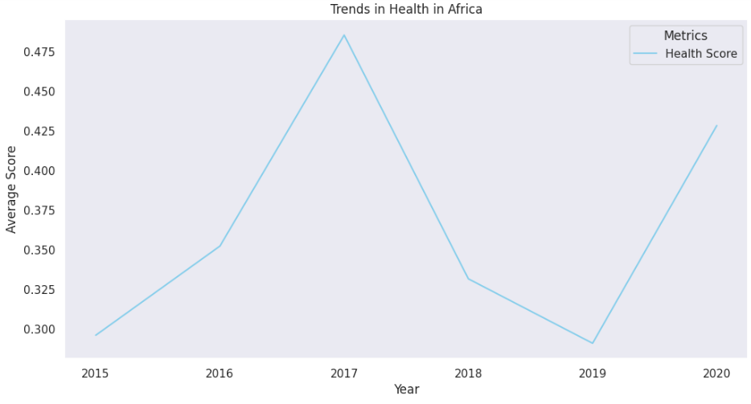

The bottom line is that the observed trends in Africa during 2019-2020, where health and happiness levels increased while GDP per capita decreased amidst the COVID-19 pandemic, are multifaceted. Peer-reviewed literature suggests that effective public health measures, community resilience, and adaptive behaviors may have mitigated some economic challenges. Cultural values and community cohesion also played roles in influencing subjective well-being.